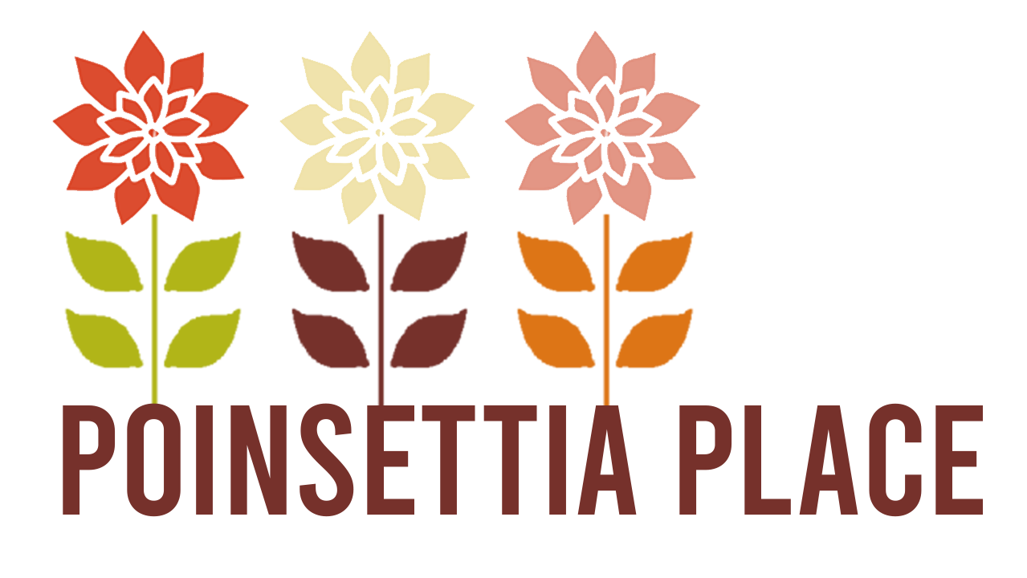

El Monte Affordable Housing Program Application

APPLICATION AND INCOME CERTIFICATION FORM
Income certification is required as one of the stipulations of purchasing an affordable home inclusionary housing program with the City of El Monte.
NAME OF APPLICANT: _______________________________________________________
PRESENT HOME ADDRESS: ___________________________________________________
Home Phone: ___________________________________________________________________
Cell Phone: ______________________________________________________________________
Email Address: _________________________________________________________________
Work Address: _________________________________________________________________
Work Phone: ___________________________________________________________________

NAME OF APPLICANT: _______________________________________________________
PRESENT HOME ADDRESS: ___________________________________________________
Home Phone: ___________________________________________________________________
Cell Phone: ______________________________________________________________________
Email Address: _________________________________________________________________
Work Address: _________________________________________________________________
Work Phone: ___________________________________________________________________

Names of Members of Household | Relationship to Head of Household | Date of Birth | Employer or Other Source of Income | Annual Gross Income
 | Head

Anticipated gross income of all adults during the next 12 month period: $________________
Total value of all assets (excluding personal property): $________________
Income expected from assets during next 12 month period: $________________
TOTAL OF ALL INCOME DURING NEXT 12 MONTH PERIOD: $________________

Required Documents for Affordable Housing Program Application
- Government-issued photo ID (driver’s license, passport, or state ID)
- Social Security number or ITIN documentation
- Most recent 30 days of pay stubs
- W-2 forms for the past 2 years
- Federal tax returns for the past 2 years (all schedules)
- Bank statements for the most recent 2–3 months
- Retirement account statements (401(k), IRA, pension, etc.)
- Investment account statements (stocks, brokerage accounts, etc.)
- Documentation of down payment and closing cost funds
- Gift letter and proof of transfer if gift funds are being used
- Employment verification contact information
- Proof of additional income (bonuses, commissions, overtime, Social Security, disability, alimony, child support, etc.)
- Business tax returns and profit/loss statements (if self-employed)
- Year-to-date income statement (if self-employed)
- Explanations for large deposits appearing on bank statements
- Documentation of outstanding debts, loans, or obligations

Note: Additional documentation may be requested during underwriting.

Once completed, please email documents and application to:

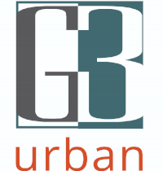
  Mary Gradinger / Vice President of Sales
  G3 Urban
  m: 925.876.9985
  w: www.G3Urban.com
  e: Mary@g3urban.com
  CA DRE# 00960311

